**Example 1: C++ Program to Find Average of N Numbers using for loop.**

|  |
| --- |
| #include <iostream>  using namespace std;  int main()  {  int num;  float total = 0, y;  float average;  cout << "Enter the number of elements to calculate the average::\n";  cin >> num;    cout << "Enter " << num << " elements one by one\n\n";  for(int i = 1; i <= num; i++)  {  cout<<"Enter the number: "<<i<<" :";  cin >> y;  total =total+ y;  }  average = total/ num;  cout << "\nThe average of the entered input numbers is = " << average;  return 0;  } |

Output

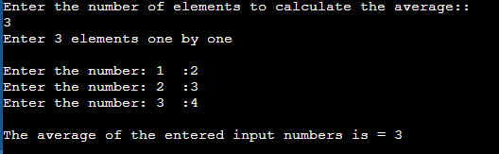

**Example 2: Printing and counting odd and even numbers using for Loop**

|  |
| --- |
| #include<iostream>  using namespace std;  int main()  {  int i,n,even=0,odd=0;  cout<<"\nEnter the Ending value:";  cin>>n;  cout<<"\nEven numbers:";  for(i=0;i<=n;i++)  {  if(i%2==0)  {  cout<<"\n"<<i;  even++;  }  }  cout<<"\nOdd numbers:";  for(i=1;i<=n;i++)  {  if(i%2==1)  {  cout<<"\n"<<i;  odd++;  }  }  cout<<"\nTotal even numbers:"<<even;  cout<<"\nTotal odd numbers:"<<odd;  return 0;  } |

Output

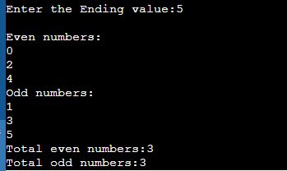

**Example 1: C++ program to display 7 days a weeks.**

|  |
| --- |
| #include <iostream>  using namespace std;  int main() {  int week = 7;  for (int i = 1; i <= week; ++i) {  switch (i) {  case 1:  cout << i << " Saturday" << endl;  break;  case 2:  cout << i << " Sunday" << endl;  break;  case 3:  cout << i << " Monday" << endl;  break;  case 4:  cout << i << " Tuesday" << endl;  break;  case 5:  cout << i << " Wednesday" << endl;  break;  case 6:  cout << i << " Thursday" << endl;  break;  case 7:  cout << i << " Friday" << endl;  break;  }  }  return 0;  } |

Output

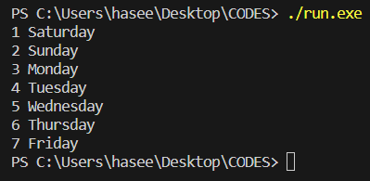

**Example 2: C++ program to display a pattern.**

**\* * * * * * * * * \***

**\* * * * * * * * * \***

**\* * * * * * * * * \***

**\* * * * * * * * * \***

**\* * * * * * * * * \***

|  |
| --- |
| #include <iostream>  using namespace std;  int main()  {  int rows = 10;  int columns = 5;  for (int i = 1; i <= rows; i++)  {  for (int j = 1; j <= columns; j++)  {  cout << "* ";  }  cout << endl;  }  return 0;  } |

Output

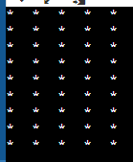

**Example 3: Program to Print a Half-Pyramid Using \***

**\***

**\* \***

**\* * \***

**\* * * \***

**\* * * * \***

|  |
| --- |
| #include <iostream>  using namespace std;  int main() {  int rows;  cout << "Enter number of rows: ";  cin >> rows;  for(int i = 1; i <= rows; ++i) {  for(int j = 1; j <= i; ++j) {  cout << "* ";  }  cout << "\n";  }  return 0;  } |

Output

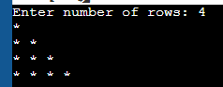

**Example 4: Program to Print a Half-Pyramid Using Numbers.**

**1**

**1 2**

**1 2 3**

**1 2 3 4**

**1 2 3 4 5**

|  |
| --- |
| #include <iostream>  using namespace std;  int main() {  int rows;  cout << "Enter number of rows: ";  cin >> rows;  for(int i = 1; i <= rows; ++i) {  for(int j = 1; j <= i; ++j) {  cout << j << " ";  }  cout << "\n";  }  return 0;  } |

Output

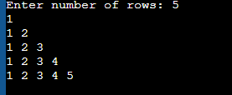

**Example 5: Program to Print a Inverted Half-Pyramid Using *.**

**\* * * * \***

**\* * * \***

**\* * \***

**\* \***

**\***

|  |
| --- |
| #include <iostream>  using namespace std;  int main() {  int rows;  cout << "Enter number of rows: ";  cin >> rows;  for(int i = rows; i >= 1; --i) {  for(int j = 1; j <= i; ++j) {  cout << "* ";  }  cout << endl;  }    return 0;  } |

Output

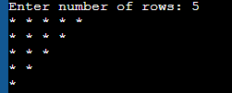

**Example 6: Write a program in c++ for Inverted Half-Pyramid Using Number.**

**1 2 3 4 5**

**1 2 3 4**

**1 2 3**

**1 2**

**1**

|  |
| --- |
| #include <iostream>  using namespace std;  int main() {  int rows;  cout << "Enter number of rows: ";  cin >> rows;  for(int i = rows; i >= 1; --i)  {  for(int j = 1; j <= i; ++j)  {  cout << j << " ";  }  cout << endl;  }  return 0;  } |

Ouput

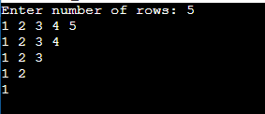

**Example 7: Program to Print an Inverted Half-Pyramid Using *.**

|  |
| --- |
| #include <iostream>  using namespace std;  int main() {  int space, rows;  cout <<"Enter number of rows: ";  cin >> rows;  for(int i = 1, k = 0; i <= rows; ++i, k = 0) {  for(space = 1; space <= rows-i; ++space) {  cout <<" ";  }  while(k != 2*i-1) {  cout << "* ";  ++k;  }  cout << endl;  }  return 0;  } |

Output

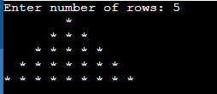

**Example 8:**

1

2 3

4 5 6

7 8 9 10

|  |
| --- |
| #include <iostream>  using namespace std;  int main() {  int rows, number = 1;  cout << "Enter number of rows: ";  cin >> rows;  for(int i = 1; i <= rows; i++) {  for(int j = 1; j <= i; ++j) {  cout << number << " ";  ++number;  }  cout << endl;  }  return 0;  } |

Output

